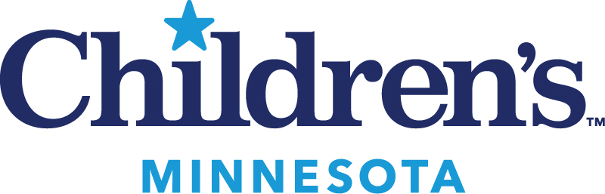Children’s Hospitals and Clinics – Minnesota
Minneapolis and St. Paul
PGY2 Supplemental Application Materials

NAME:
**Upload all application materials to the PhORCAS website by January 5th.

Professional Interests
What are your current areas of interest within pediatrics? (Rank no more than 5 areas with “1” being the highest.)

____ Ambulatory medicine | ____ Oncology
____ Cardiology | ____ Pain management
____ Cystic Fibrosis | ____ Patient safety
____ Diabetes management | ____ Pediatric critical care
____ Emergency medicine | ____ Pediatric psychiatry
____ General pediatrics | ____ Pharmacy mgmt/administration
____ Infectious diseases | ____ Pulmonary medicine
____ Neonatal critical care | ____ Other
____ Neurology

What types of pharmacy projects have you worked on during your PGY1 residency and/or prior work experience?

What types of pharmacy projects would you like to initiate or participate in during your PGY2 residency?

Career Goals
- What are your reasons for pursuing the PGY2 residency at Children’s Hospitals and Clinics of Minnesota?

- What are your professional career goals three years after completing your PGY2 residency?

- What are your professional career goals seven-to-ten years after completing your PGY2 residency?

- What’s the most important thing we should know about you that is not in your application or resume?

