Qualifying for a Virtual Visit

- Must be in Minnesota at the time of the Virtual Visit (May be acceptable in other state during COVID. Check with your clinic provider.)
- Must have an active Children’s Consent on record.
- Patient access to a computer, laptop, tablet or smartphone with broadband internet, Wi-Fi, 4G or 5G
  - Smartphones or tablets are recommended for Virtual Visits
- MyChildren’s portal account is highly recommended
  - Note: If unable to enroll in My Children’s please reach out to your clinic about email option
- Download VidyoMobile App or VidyoDesktop to your device
- Please notify Children’s in advance if an Interpreter is needed

Device Recommendations

Smartphone recommendations for VidyoMobile app
- iPhone iOS 13.x or higher
- Android version 10.x or higher

Tablet recommendations for VidyoMobile app
- iPadOs 13.x or higher
- Request Desktop Website must be turned OFF in Safari under iPad Settings
  - Open Settings, tap Safari, under Settings and Websites tap Request Desktop Website, turn off All Websites (Join with the second bullet point)
- Android version 10.x or higher

Laptop or PC Recommendations for VidyoDesktop
- Functioning webcam, microphone and speakers as part of your device setup
- Google Chrome is preferred for Windows devices
- Safari is preferred for Apple devices
- Windows 7,8, 10 or macOS Catalina (10.15)
Note: Chromebook is NOT compatible

Downloading Vidyo

To download VidyoMobile to your SmartPhone or Tablet (Preferred)
- Download VidyoMobile from the App Store or Play Store
  - After downloading, open the app and allow access to camera and microphone. Leave the Portal field blank.
Note: A Virtual Visit will use cellular data if your device is not connected to Wi-Fi. An unlimited data plan is highly recommended if using cellular data.

To download VidyoDesktop to your laptop or PC
- Download VidyoDesktop by entering https://telemed.vtc.childrensmn.org into your web browser and follow the prompts to install
- After the download is complete, you will be asked for a portal, username and password. Leave all fields blank.

Day of Virtual Visit
Note: If you would like other family members to join from another device, you can share the virtual visit link with them by copying the link and sending it via email or text.

Launching your Virtual Visit with VidyoMobile

- Log in to My Children’s through the Children’s MN website https://www.childrensmn.org/mychildrens/
  - If link is being sent through email, open message sent by the clinic and skip to step 5.
- Click on the pink Sign in Here button.
- Enter your MyChildren’s login information and click sign in. If you forgot your password, click on Forgot Your Password.
- Go to your Messages inbox and open the message for the Virtual Visit.
- Tap on the link and the Vidyo screen will display. Tap Join Conference.
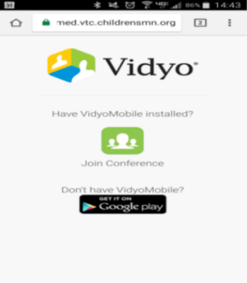

- Enter the patient’s name in the Name field, then tap Join.
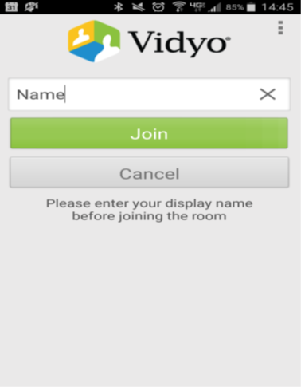
- Wait for the Children’s provider to join you.

Launching your Virtual Visit with VidyoDesktop
- Login to My Children’s through the Children’s MN website https://www.childrensmn.org/mychildrens/
  - If link is being sent through email, open message sent by the clinic and skip to step 5.
- Click on the pink Sign in Here button
- Enter your login information and click sign in. If you forgot your password, click on Forgot Your Password.
- Go to your Messages inbox and open the message for the Virtual Visit.
- Click on or copy and paste the link into your web browser.
- Enter your name, child’s name or family name and click Connect to join the Virtual Visit Room. Wait for Children’s Provider to join.
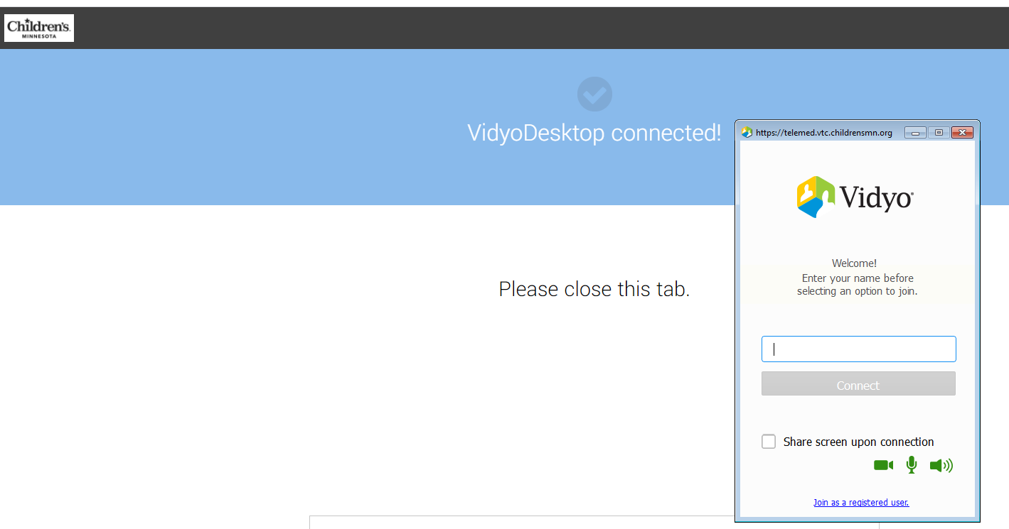
.

Tips for a Successful Virtual Visit
- If connected to Wi-Fi, being as close to your modem/router as possible
- Close any unnecessary programs on your device.
- Adjust lighting- Try turning on overhead lights and blocking light from windows, which can lead to too much background light in the video.
- Other family members who are using the internet for streaming video, gaming, etc can impact the quality of the virtual visit. It is recommended that those activities be suspended during the virtual visit.

Troubleshooting
- If joining via Smartphone, you cannot join the virtual visit and be on a phone call at the same time. Hang up the phone call before attempting to join.
- Unable to install VidyoMobile App or VidyoDesktop on your device and/or failure when testing your connection?
- Restart the device and try again.
- Call 952-992-5400 if the restart does not fix the problem.

